Major Project ECE A2 Batch 1

**DESIGN AND IMPLEMENTATION OF**

**TEXT TO BRAILLE CONVERTER**

**ABSTRACT**

Braille is a tactile system to represent text. It is not a language but is a code. A text in braille consists of several braille cell where each cell represents an alphabet or symbol. A single cell consists of 6 individual dots. Combination of raising high and raising low of these pins compose an alphabet. There is a standard braille code for each alphabet of most of the languages. Generally, texts embossed on paper, and visually impaired persons move finger over the dots to read the text.

Braille technology is growing by many folds with the given technical advancements in various ﬁelds of science. With Braille code, many languages such as English, French, and Spanish may be written and read. Many people use this code in their native language all over the world, thereby providing literacy to one and all.

The aim is to design a Text to Braille Converter using Arduino. An attempt will be made to build an App sent the necessary text input to the Braille Module via Bluetooth. When the text received to the braille module, it converts the text to Braille language. When the users keep their fingers on the module, they sense the high and low cells positions and can detect the text.

**DESIGN IMPLEMENTATION AND ISSUES:**

Smartphone apps have expanded the utility of the Smartphone way beyond direct communication. We now have apps that help us do daily tasks with ease. The same approach has been applied to cater to the visually challenged community.

The text from the app is fed as input via Bluetooth. The text analysis module compares the text given as input from a file to its equivalent English alphabet and numbers. The built-in libraries and file handling functions are used to convert files into braille pattern. The programmed script analyses the text converts it into simple, readable text and feeds the text letter by letter to the Arduino board. Using an Arduino Uno, text is transformed into braille code by splitting each letter from the text, including punctuations. This braille code is represented on a 3x2 matrix (6 dots) and is identified by a high or low output for each dot.

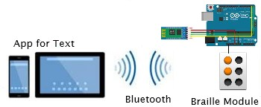

Fig 1: Implementation

Arduino Programming makes the application easy to modify and add new characters or symbols. The usage of a microcontroller extends the scope of the device for any further extension of features. But an extension of this conversion to any other language is a very complex task.

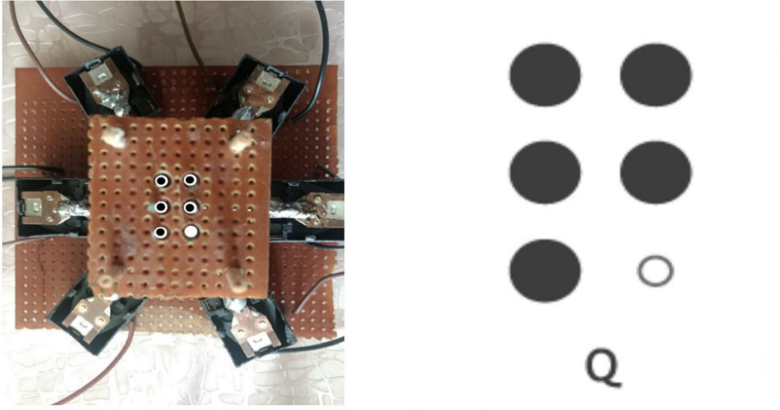

Fig 2: Braille for letter Q

The mechanism consists of 6 metallic control arms whose movement is directly related to the movement of the relays. The entire system is dependent on the tactile senses of the user. The user has to place his/her hand on the interface set up to interpret the output. The systems' performance was tested for a set of English Alphabets (A-Z), and Arabic Numbers (0–9) and the observations were analysed.

**APPLICATIONS:**

Normal human beings read braille code with their eyes whereas the visually impaired person with their fingers. The following are the applications of the proposed project work.

1. The converter can be used to develop a sophisticated keyboard for Blind people.
2. A braille watch is a portable timepiece used by the blind or visually impaired to tell time. This application can be used in braille watch to make digital.
3. Many prototype devices and apps can be built based on the text to braille converter.
4. This app can be used to interface any other external apps making the communication to visually impaired easier.

**REFERENCES:**

1. Noushad S, Zafar Iqbal M, "Single cell Bangla braille book reader for visually impaired people", *IEEE*, Nov.2018.
2. Alexander R, O'Modhrain S, Brent Gillespie R, Matthew W, Rodger M, "Refreshing refreshable braille displays", *IEEE,* pp. 287–297, Oct.2015.
3. Abhinav K, Kishor B, "Low cost e-book reading device for blind people", *IEEE*, pp 516–520, Jun.2015.
4. Xiaosong W, Seong-Hyok K, Haihong Z, Chang-Hyeon J, Mark GA, "A refreshable braille cell based on pneumatic microbubble actuators", *J Microelectromech Syst,* pp. 908–916, Jan.2012.
5. Matsumoto Y, Arouette X, Ninomiya T, Okayama Y, Miki N, "Vibrational braille code display with MEMS-based hydraulic displacement amplification mechanism" *IEEE*, pp. 19–22, Mar.2010.
6. Green SR, Gregory BJ, Gupta NK, "Dynamic braille display utilizing phase-change microactuators", *IEEE*, pp. 307–310. Apr.2006.

**Project Batch Names & Roll No’s:**

**Guggilam Lohitha Lakshmi & 221710402015**

**Uppula Soundharya Lahari & 221710402062**

**Signature of the Guide:**

**Prof. P. Trinatha Rao**

**Professor**

**Turlapati Bharadwaj & 221710402061**

**K Vishnu Kalyan Chakravarthi & 221710402022**